Meda Pharmaceuticals Ltd
Skyway House
Parsonage Road
Takeley
Bishop's Stortford
CM22 6PU

9th December 2013

Dear Sir / Madam

Meda Pharmaceuticals Ltd is to increase the supply of its adrenaline auto-injector, EpiPen® to meet additional patient demand

Those patients currently carrying specific batches of Jext® adrenaline auto-injectors (refer to MHRA recall notification) are advised to visit their healthcare professional who will provide them with an alternative prescription for EpiPen® adrenaline auto-injector. Accompanying guidance and training around how to administer the treatment using the “swing and jab” technique will be required by patients.

In order to meet the demand created by this recall, Meda Pharmaceuticals has sourced additional stocks from the US; due to this some EpiPen® adrenaline auto-injectors dispensed will have a US label on the actual device but this is the only difference (see overleaf). US stocks have been repacked in the UK livery and will contain additional patient safety information, regarding the correct method of administration.

Patients can request an EpiPen® training device and access more information about EpiPen® adrenaline auto-injector by visiting http://www.epipen.co.uk/patient/.

Yours sincerely

John Eshelby
Senior Brand Manager

US EpiPen® adrenaline auto-injector labelling
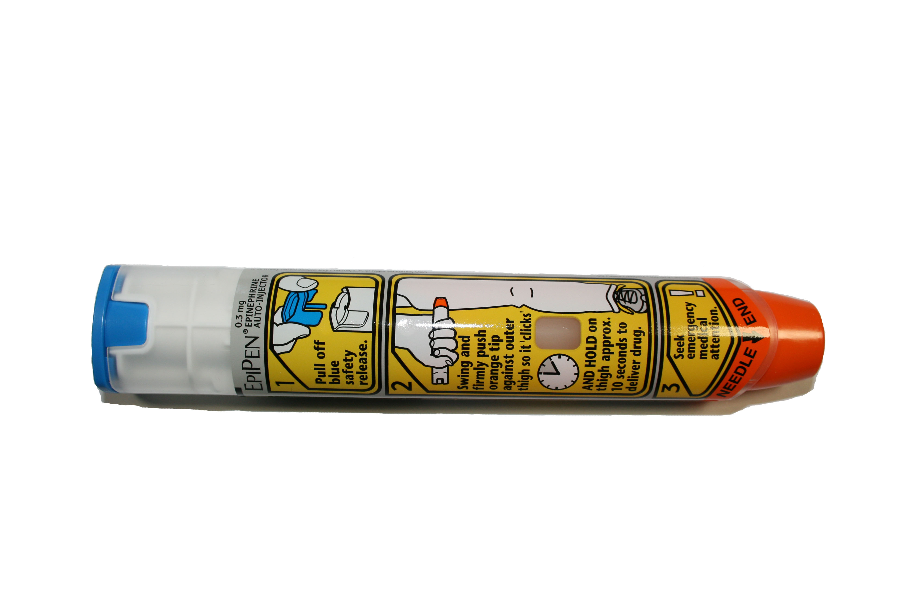

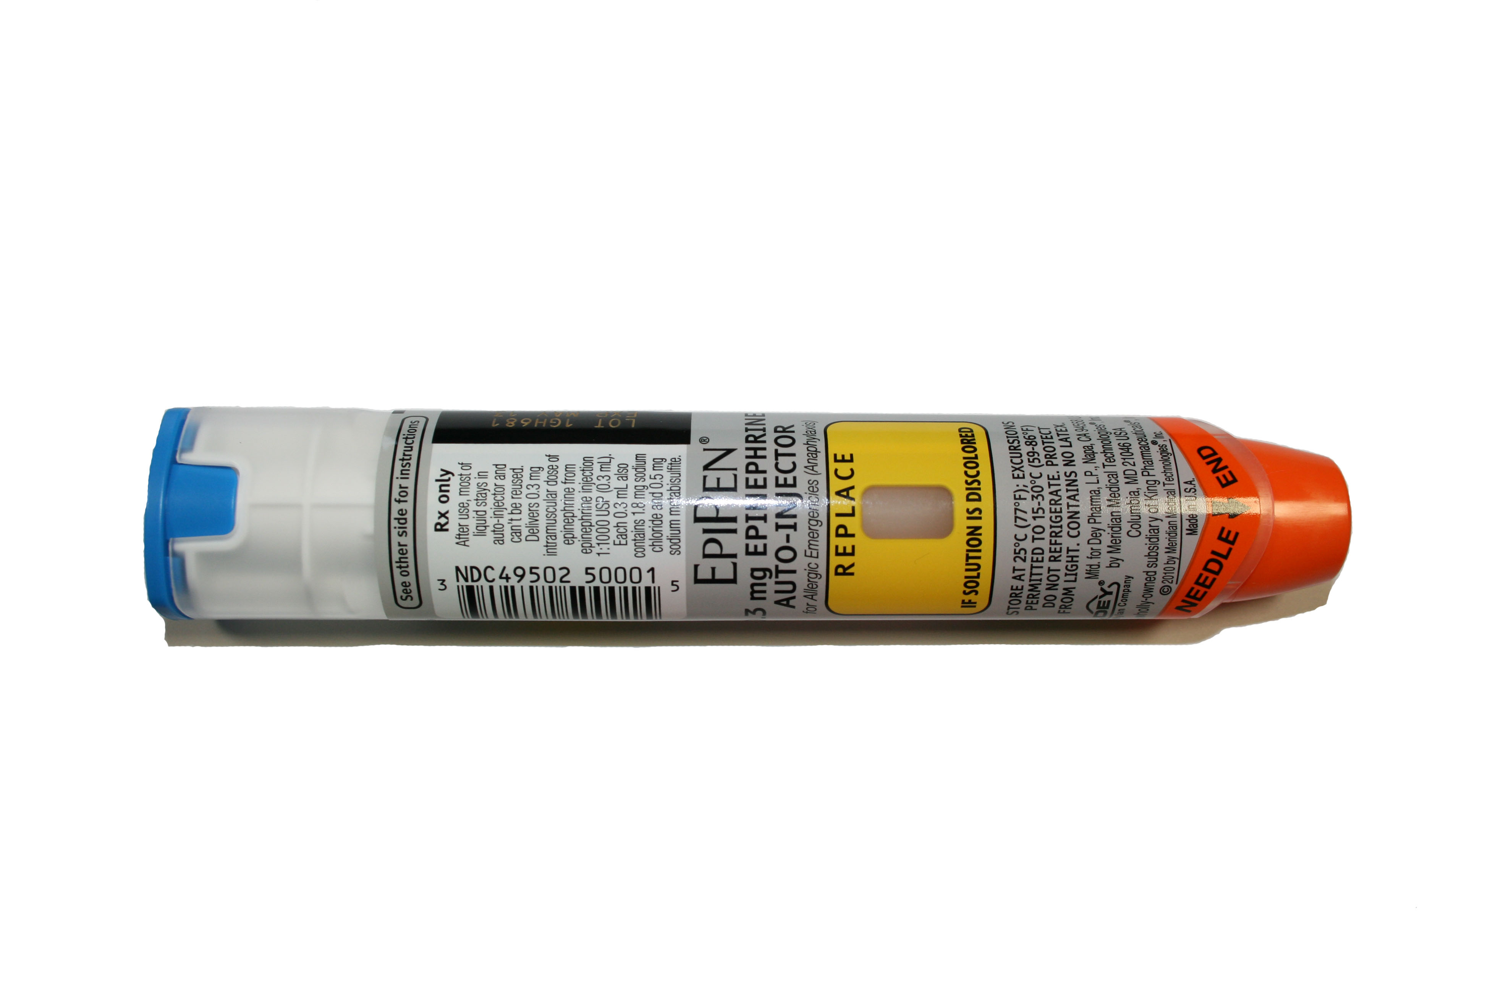
UK EpiPen® adrenaline auto-injector labelling

