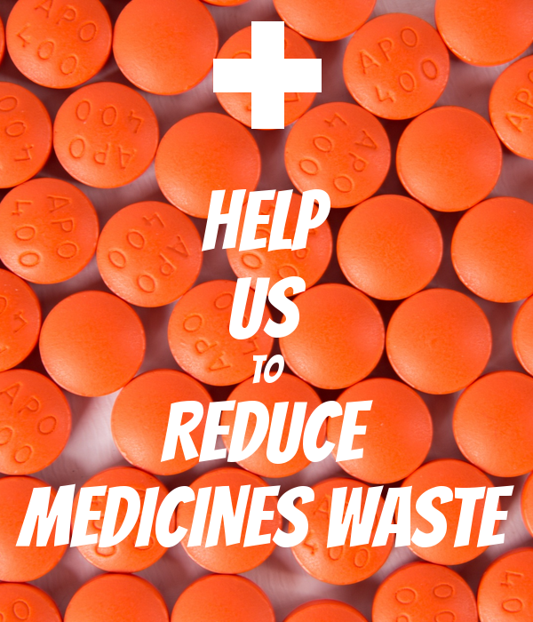

Wednesday 5th October
6.30pm – 8.30pm
Stadium of Light, Sunderland

Following the success of the Community Pharmacy Engagement Event in March, a future event has been organised by NHS Sunderland CCG. We have new projects to let community pharmacy teams in Sunderland know about as well as updates from work already going on.

We also jointly face a challenge of reducing medicines waste –
an estimated £300,000 to £570,000 of medication is wasted in Sunderland
each year. We want to hear your ideas about how we can work together to support the reduction of this.

The event will be made up a series of stands where representatives for the various pieces of work will be available to provide information, answer questions, hand out resources, and listen to feedback.

These will include:
- Pharmacy transfer of care
- Sunderland Community Integrated Teams
- Insulin Safety
- GP practice pharmacist support
- Live Life Well Service
- Inhaler “know how”
- Sunderland CCG Medicine Waste Challenge
- Patient Safety Reporting for Medicines and Pharmacy
- More to be confirmed (see PharmOutcomes for updates)

The event is open to pharmacists, pre-registration pharmacists, locums, pharmacy technicians and all other pharmacy support staff working in Sunderland. All attendees will be provided with a certificate of attendance.

A hot meal will be provided.

To book a place, please register for the event online at http://tinyurl.com/zkurv67 or ring 0191 5128487
by Friday 30th September 2016. As this event was extremely popular in March, we encourage you to book early!

