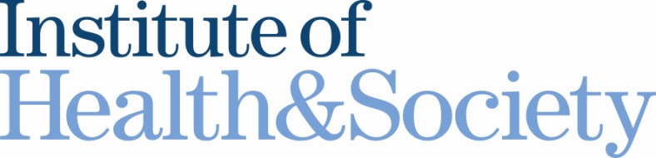

Shared Decision Making & Medicines II

Hosted by the North East Shared Decision Making Community of Interest

Monday 23rd July 2012
6.00-8.00pm
Seminar Room, Baddiley Clark Building
Newcastle University

Drawing on our earlier event in March the purpose of this meeting is to explore how we might move forward shared decision making in the context of medicines in the North East region with specific action planning and objective setting.

Opportunities for discussion, practical examples and thoughts and insights from:

Neal Maskrey (Programme Director of the National Prescribing Centre at National Institute of Health and Clinical Excellence)

Who should attend?
Pharmacists, clinicians, allied health professionals, service managers, commissioners, academics & anyone else interested in the involvement of patients in decisions about medicines.

Registration
To sign up for this event please contact Alison Etherington
Email: alison.etherington@ncl.ac.uk Telephone 0191 2227382

